|  |  |  |
| --- | --- | --- |
| **C++ Programming** | **Student**  **number** | **21300691** |
| **Homework 1** | **Name** | **Cheung, Won Sik** |

1. Problem Definition

I want to make a brick-breaking game. However, I do not have enough time during the semester, so I want to write a ball-bouncing program. If you just bounce the ball is not fun, add another function.

1. Design of your program

There are three options. First, it is an option to draw bricks on maps in the game. Secondly, there is a brick in the place where the ball passes after playing the game. Finally, erase all the bricks on the map.

1. Primary codes with comments

Main function draw map and give 3 options to player. If player enter ESC than program end.

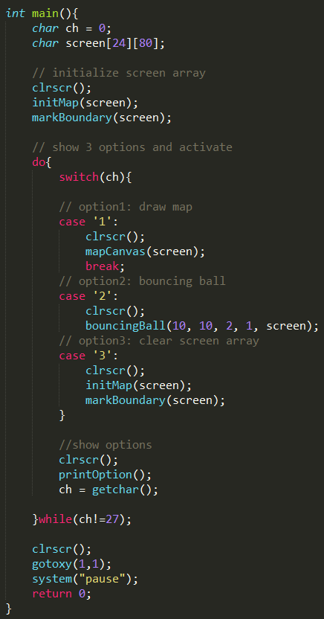

gotoxy and clrscr

these functions allow move position where I want to go and erase entire screen.

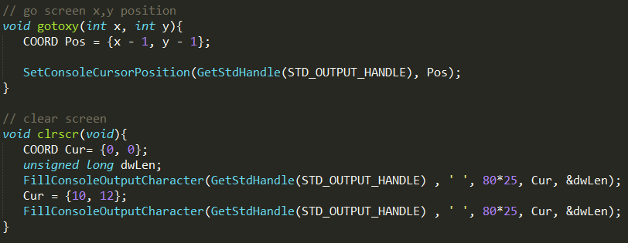

mapCanvas

this function allow draw block in screen

Initialize part

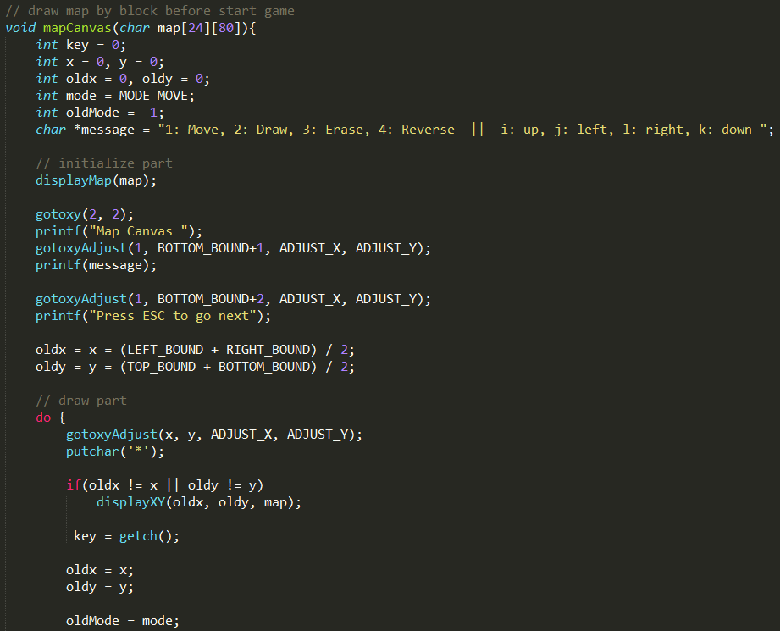

Draw part

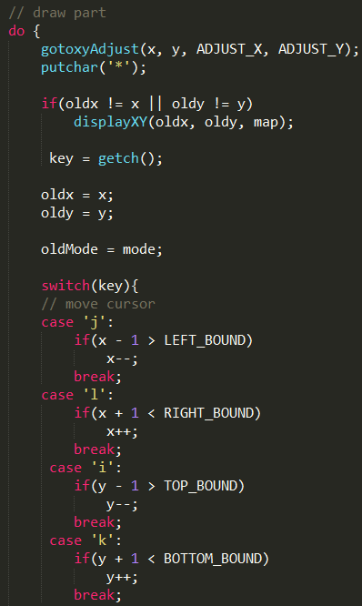

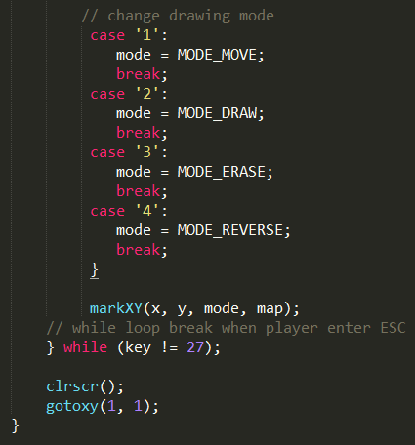

Bouncing Ball

This function bounces the ball and draws the block where the ball passes.

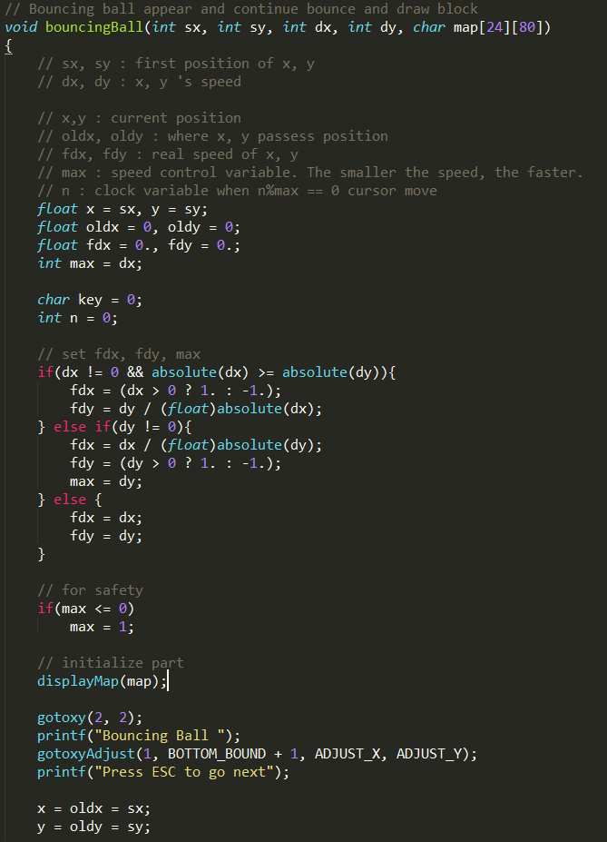

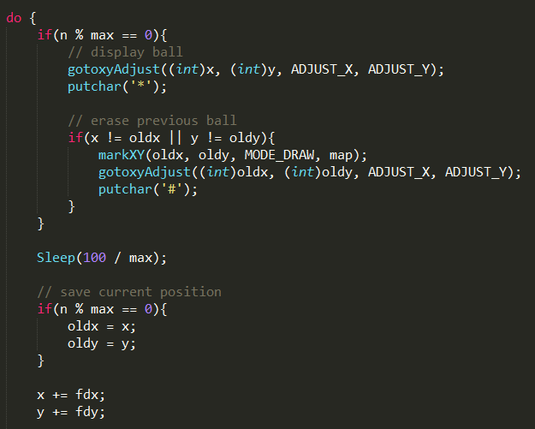

Check when ball meet wall

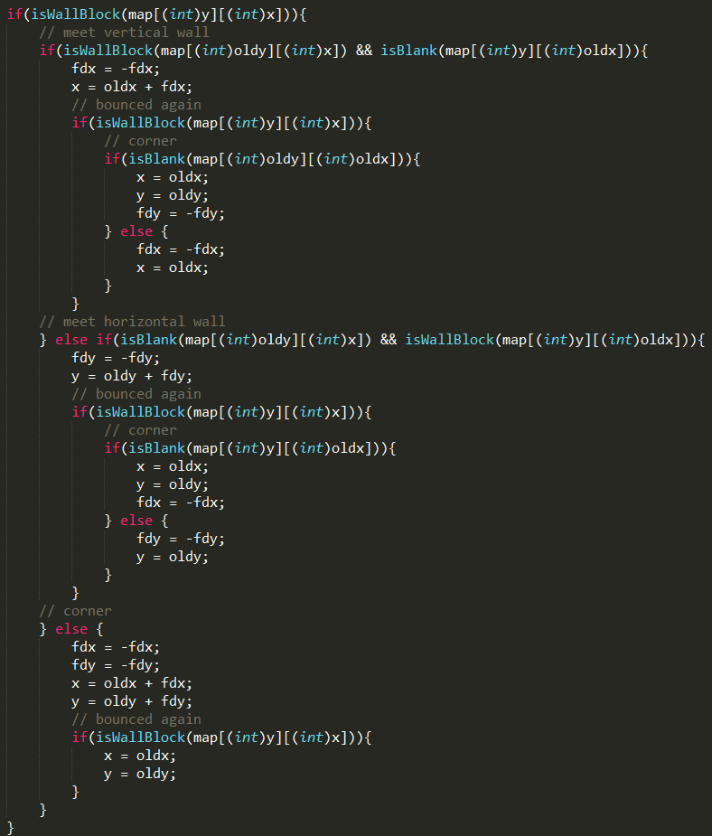

4. Screen show of the result

Options

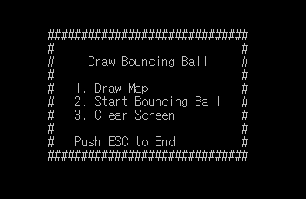

Option No.1 Draw Map

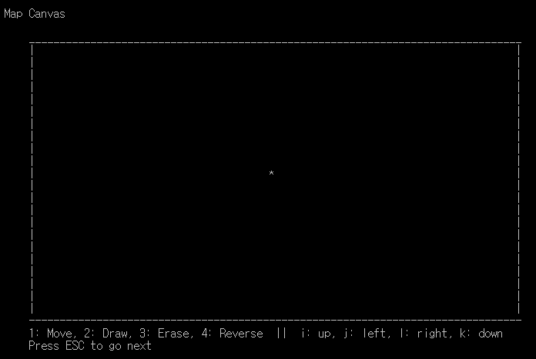

Move Cursor

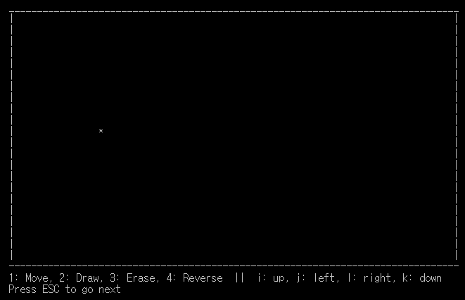

Draw Cursor

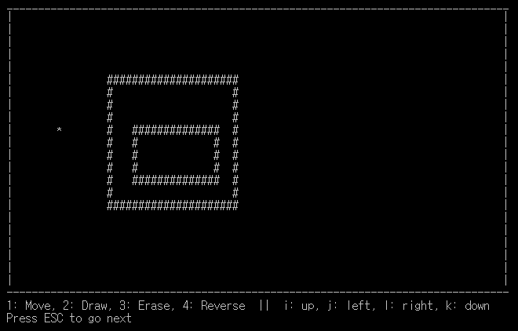

Erase Cursor

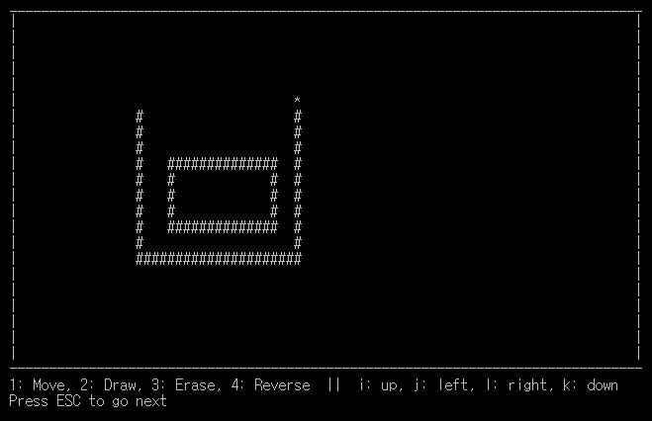

Reverse Cursor

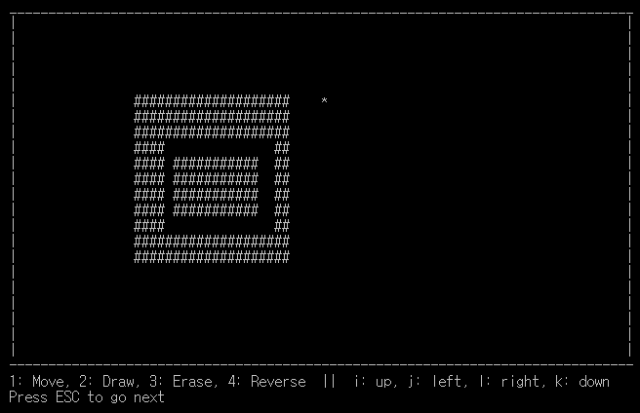

Option No.2 Bouncing Ball

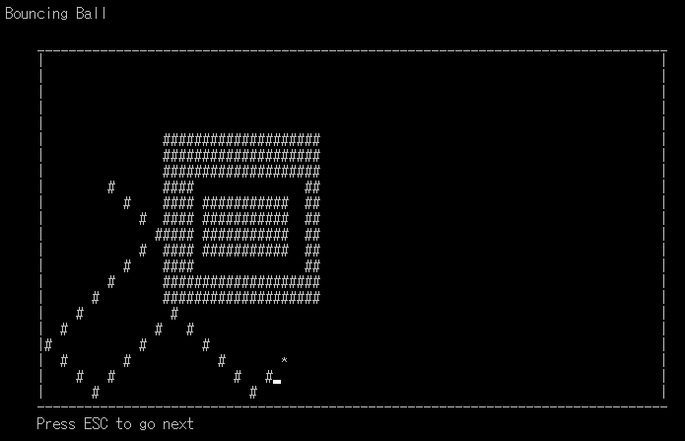

Option No.3 Clear Screen

